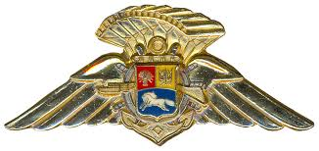

Logo makes your letter look more official.

**Joint Federal Military Services**

*Parachute Training School*

*Malta, UCF*

22 Jan 2022

Alternatively, as appropriate:

* Back and Chest
* Back, Chest, and Seat

To whom it concerns:

**CERTIFICATE OF COMPETENCY – SERGEANT CARL JENKINS**

1. This is to certify that Sergeant Carl Jenkins, 3rd Infantry Battalion, 1st Southern Brigade has been properly supervised in the packing of Back and Seat Type reserve parachutes. He has packed in excess of 100 Back Type and 100 Seat Type reserve parachutes in accordance with the manufacturer’s instructions.
2. Sergeant Jenkins has served with the Joint Federal Military Services Parachute Training School as a Parachute Rigger for the past sixteen years and has received training on FAR Part 65, subsections A & F.

Must show minimum 3 year’s experience.

1. Sergeant Jenkins meets all requirements for a Master Rigger Certificate and I recommend he be tested for this rating.

1. Point of contact for this memorandum is the undersigned, at +1-202-456-1414 or +39-06-69-88-1022.
2. For your attention and action please.

The number 100 must appear before each two types. For three ratings, the third number can be 20 or greater.

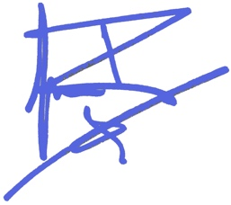

“Wet” ink signature, or digital signature (Echosign, Identrust, Appligent, Arx, DocuSign, etc.)

**Johnny Rico**

**Commandant**

Command letter should be signed by commander, not just first-line supervisor.

**JFMS Parachute Training School**