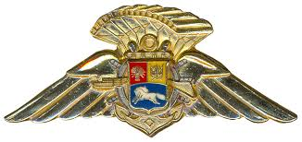

Logo makes your letter look more official.

**Joint Federal Military Services**

*Parachute Training School*

*Malta, UCF*

22 Jan 2022

Alternatively, as appropriate:

* Back
* Back and Seat
* Back, Chest, and Seat

To whom it concerns:

**CERTIFICATE OF COMPETENCY – PRIVATE CARL JENKINS**

1. This is to certify that Private Carl Jenkins, 3rd Infantry Battalion, 1st Southern Brigade has been properly supervised in the packing of Back and Chest Type reserve parachutes. He has packed in excess of 20 Back Type and 20 Chest Type reserve parachutes in accordance with the manufacturer’s instructions.
2. Private Jenkins has served with the Joint Federal Military Services Parachute Training School as a Parachute Rigger for the past six months and has received training on FAR Part 65, subsections A & F.

1. Private Jenkins meets all requirements for a Senior Rigger Certificate and I recommend he be tested for this rating.

1. Point of contact for this memorandum is the undersigned, at +1-202-456-1414 or +39-06-69-88-1022.
2. For your attention and action please.

The number 20 must appear before each type.

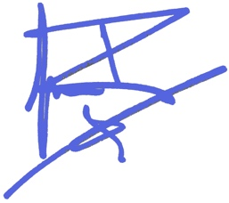

“Wet” ink signature, or digital signature (Echosign, Identrust, Appligent, Arx, DocuSign, etc.)

**Johnny Rico**

Command letter should be signed by commander, not just first-line supervisor.

**Commandant**

**JFMS Parachute Training School**